­­



Submitted to

:

Sir.Aqib Adeel

Quiz # 1

***BS***

***-***

***Software Engineering***

***1***

***ST***

***-***

***E***

Title: Lab Reports of MS Power Point

IICT

Hamza Mehmood

Roll# SP-21-110

NUML

-

S21

-

2352

9



**National University of Modern Languages**

Introduction to MS Power Point

# Week 5

**National University of Modern Languages Sector H-9, Islamabad, Pakistan.**



**Department of Software Engineering**

**Course Title: Introduction to Information & Computer Technology**

**Student Name: Hamza Mehmood**

**Roll Number: SP-21-110**

**Lab Number: WEEK-5 Date:**

**Lab Assessment Rubrics**

**Method:** Lab report and instructor observation during Lab session **Outcome Assessed:**

1. Ability to analyze and design solutions to conduct experiments (Psychomotor).
2. Ability to perform in a team (Affective).
3. Ability to apply and comprehend modern engineering tools to develop skills for engineering knowledge and being able to design report and documentation (Psychomotor).

|  |  |  |  |  |
| --- | --- | --- | --- | --- |
| **Performance** | **Exceeds Expectation (4-5)** | **Meets Expectation (2-3)** | **Does not meet Expectation (1)** | **Marks** |
| 1. Realization of  Experiment [c] | Chooses the required yet relevant equipment to perform the experiment establishes setup diagrams of equipment connection or wiring. | Effective guidance is required to choose relevant tools for the experiment and also to develop well connected wiring diagram. | Fails to select the required equipments/ tools to perform the experiment or wiring diagram seriously lack clarity or appear ambiguous. |  |
| 2. Teamwork [b] | An active cooperation develops among group members to support the execution of the experiment. | Effectively cooperates with the group members  to perform the experiment. | Negatively affects the other group members and creates hindrance in successful performance or completion of experiment. |  |
| 3. Conducting Experiment [a] | A careful selection of equipment, wiring is done under supervision of instructor for effective operation and task completion. | Carefully examines the  equipment, wiring of all components and calibrate experiments with very few errors. | Incapable of calibrating the suitable equipment and wiring with inaccurate equipment operation. |  |
| 4. Laboratory  Safety Rules [a] | Safety rules and procedures are carefully observed during the experiment. | Scrutiny observes the prescribed safety measures with very minor deviation. | Does not observe the safety rules during experiments. |  |
| 5. Data Collection  [a] | Data collection is carefully planned to achieve experimental objective. | Data collection is carefully planned to get experimental objectives with very minor mistakes. | Incapable of planning the data collection to acquire the experimental objective or the collected data is inappropriate or incomplete. |  |
| 6. Report writing  [c] | Properly written with all results. | Writing report with minor error. | Incomplete Lab report |  |

**Total Marks Obtained:**

**Instructor’s Signature:**

**INTRODUCTION:**

PowerPoint (PPT) is a powerful, easy-to-use presentation graphics software program which allows you to create professional-looking electronic slide shows. PPT is used to present information in an organized manner to an individual or group.

Home tab

#### Slides

|  |
| --- |
|  |

**New Slide** - Button with Drop-Down. The button inserts a new blank Title and Content Slide. The drop-down contains the slides: Title Slide, Title and Content, Duplicate Selected Slides, Slides from Outline and Reuse Slides.  
**Layout** - Drop-Down. The drop-down contains the commands: Title Slide and Title and Content.  
**Reset** - Reset the position, size and formatting of the slide placeholders to their default settings.  
**Section** – it is used for add different section in slides.

#### Drawing

You can quickly ..

|  |
| --- |
|  |

**Shapes** - gallery  
**Arrange** - Drop-Down. The drop-down contains the commands: Bring to Front, Send to Back, Bring Forward, Send Backward, Group, Ungroup, Regroup, Align, Rotate and Selection Pane.  
**Quick Styles** - Drop-Down. The drop-down contains the commands:  
**Shape Fill** - Button with Drop-Down. The button .. The drop-down contains the commands:  
**Shape Outline** - Button with Drop-Down. The button .. The drop-down contains the commands: Theme Colors, Standard Colors, Recent Colors, No Outline, More Outline Colors, Weight, Dashes and Arrows.  
**Shape Effects** - Drop-Down. The drop-down contains the commands: Preset, Shadow, Reflection, Glow, Soft Edges, Bevel and 3D Rotation.

### Insert Tab

#### Slides

|  |
| --- |
|  |

**New Slide** -it is used for insert new slides in document.

#### Tables

|  |
| --- |
|  |

**Table** - Drop-Down. The drop-down displays the commands: Insert Table, Draw Table and Excel Spreadsheet.

#### Illustrations

|  |
| --- |
|  |

**Shapes** - Drop-Down. Consolidated drop-down list of all the shapes including lines, rectangles, basic shapes, block arrows, equation shapes, flow charts, stars and banners and callouts.  
  
**SmartArt** - Displays the "SmartArt Graphic" dialog box which lets you choose from the following different types of smartart: list, process, cycle, hierarchy, relationship, matrix and pyramid.  
**Chart** - Inserts a Microsoft Graph chart . we already discussed about charts in MS word and it is same as in PowerPoint.

#### Links

|  |
| --- |
|  |

**Zoom** -  
**Link** - Displays the "Insert Hyperlink" dialog box. (Previously called the Hyperlink)  
**Action** - Lets you add an action to the currently selected object. Displays the "Action Settings" dialog box.

## *Audio:*

### **Purpose**

Used to insert a audio clip in a slide

### **Steps and pictures**

* Click the Insert tab.



* Click the Audio icon.

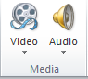

* In the drop-down menu that opens, select the Audio on My PC option.

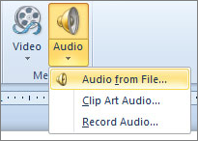

* In the Insert Audio window, find and select the sound file you want to insert into the PowerPoint slide, then click OK.
* After the sound file has been inserted, an icon that looks like a speaker with sound coming out of it appears. You can move the sound icon to another location on the slide.

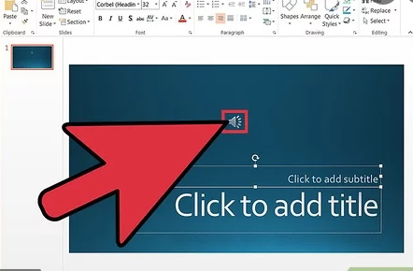

## 

## *Video:*

### **Purpose**

Used to insert a video clip in a slide

### **Steps and pictures**

* Go to the slide in which you want to insert the video.
* Click on the **‘insert’ tab**
* Click on the arrow under **‘video’**.

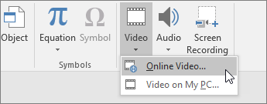

* Click on ‘video on My PC’.

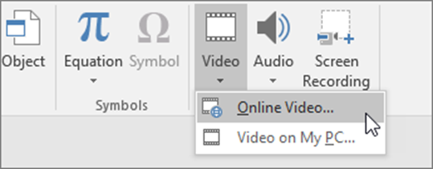

* In the **‘insert video’** box click on the video that you require to embed.
* Tap on **‘insert’.**

## *Slide number:*

### **Purpose**

Used to inset a slide number into the slides

### **Steps with picture**

* On the **Insert** tab, select **Slide Number**.

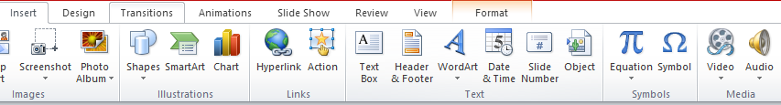

* On the **Slide** tab, check the **Slide number** box. If you don't want a **number** to appear on the title **slide**, also check the Don't show on title **slide** box.

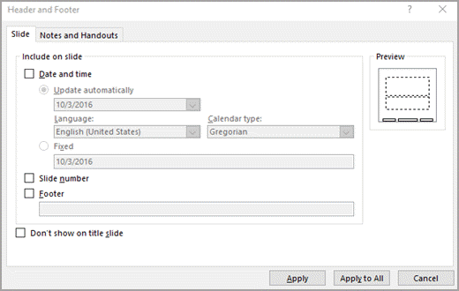

* Select Apply to All

**National University of Modern Languages**

Features of MS Power Point

# Week 6

**National University of Modern Languages Sector H-9, Islamabad, Pakistan.**



**Department of Software Engineering**

**Course Title: Introduction to Information & Computer Technology**

**Student Name: Hamza Mehmood**

**Roll Number: SP-21-110**

**Lab Number: WEEK-5 Date:**

**Lab Assessment Rubrics**

**Method:** Lab report and instructor observation during Lab session **Outcome Assessed:**

1. Ability to analyze and design solutions to conduct experiments (Psychomotor).
2. Ability to perform in a team (Affective).
3. Ability to apply and comprehend modern engineering tools to develop skills for engineering knowledge and being able to design report and documentation (Psychomotor).

|  |  |  |  |  |
| --- | --- | --- | --- | --- |
| **Performance** | **Exceeds Expectation (4-5)** | **Meets Expectation (2-3)** | **Does not meet Expectation (1)** | **Marks** |
| 1. Realization of  Experiment [c] | Chooses the required yet relevant equipment to perform the experiment establishes setup diagrams of equipment connection or wiring. | Effective guidance is required to choose relevant tools for the experiment and also to develop well connected wiring diagram. | Fails to select the required equipments/ tools to perform the experiment or wiring diagram seriously lack clarity or appear ambiguous. |  |
| 2. Teamwork [b] | An active cooperation develops among group members to support the execution of the experiment. | Effectively cooperates with the group members  to perform the experiment. | Negatively affects the other group members and creates hindrance in successful performance or completion of experiment. |  |
| 3. Conducting Experiment [a] | A careful selection of equipment, wiring is done under supervision of instructor for effective operation and task completion. | Carefully examines the  equipment, wiring of all components and calibrate experiments with very few errors. | Incapable of calibrating the suitable equipment and wiring with inaccurate equipment operation. |  |
| 4. Laboratory  Safety Rules [a] | Safety rules and procedures are carefully observed during the experiment. | Scrutiny observes the prescribed safety measures with very minor deviation. | Does not observe the safety rules during experiments. |  |
| 5. Data Collection  [a] | Data collection is carefully planned to achieve experimental objective. | Data collection is carefully planned to get experimental objectives with very minor mistakes. | Incapable of planning the data collection to acquire the experimental objective or the collected data is inappropriate or incomplete. |  |
| 6. Report writing  [c] | Properly written with all results. | Writing report with minor error. | Incomplete Lab report |  |

**Total Marks Obtained:**

**Instructor’s Signature:**

### Design Tab

#### Themes

|  |
| --- |
|  |

**Themes** - gallery  
**Colors** - Drop-Down.  
**Fonts** - Drop-Down.  
**Effects** - Drop-Down.

# Design in PowerPoint

**Themes**

1. Select the **Design** tab.
2. Select one of the **Themes**.
3. Select one of the **Variants**.

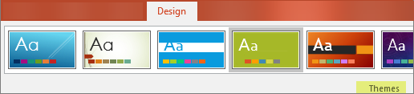

**Use PowerPoint Designer**

1. Insert one or more pictures, a list of items, or a list of dates.
2. The **Designer**panel will open. Select the design you want.

You can also bring up Designer by selecting a picture, and then selecting **Design**> **Design Ideas**.

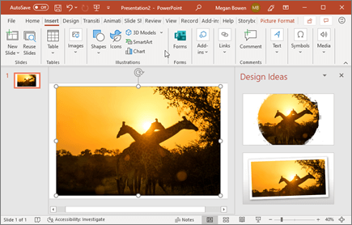

#### Variants

|  |
| --- |
|  |

**Gallery** -

#### Customize

|  |
| --- |
|  |

**Slide Size** -  
**Format Background** -

#### Designer

|  |
| --- |
|  |

**Design Ideas** –

The **Design Ideas** button should be on the right side of your screen, like you see here:

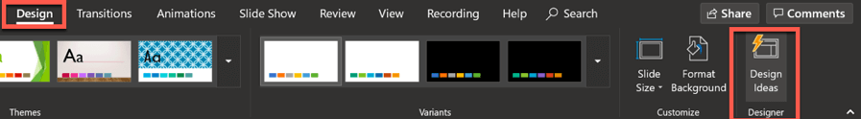

Now, let me give you a quick peek into how this tool works!

Take a look at the screenshots below. I only wrote the word ‘Hello’ on the slide, and look at what the Design Ideas panel on the right side of the screen have come up with!

This is on PowerPoint (Mac):

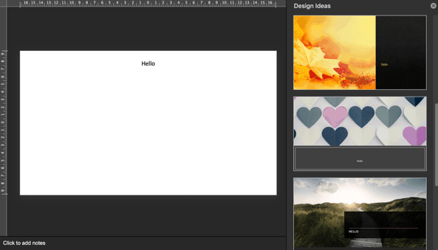

This is on PowerPoint (Windows):

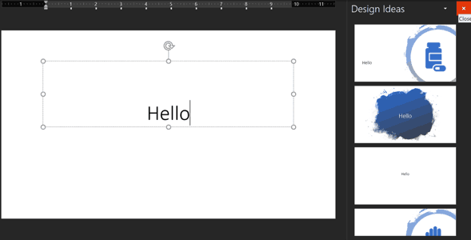

As you can see, the same text (Hello) generated vastly different design ideas. On Mac, the suggestions were visually captivating with beautiful imagery used as background. On Windows, the suggestions were a bit basic to be honest.

This is the beauty of Design Ideas – the suggestions appear to be random. So, if you’re not happy with any of the suggestions, you can give it another try and you’ll get a bunch of new ideas.

So, for the next example, I deleted a couple of characters from the ‘Hello’ text, and then retyped them again. I got the following design ideas next:

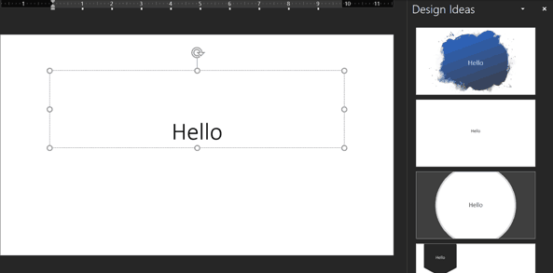

As you can see, it’s still the same text, but different design suggestions. So, if you’re not happy with the suggestions the first time around, try this technique. Perhaps the next round of design ideas may be more to your liking!

## 

## *Themes*

### **Purpose**

Used to select your favorite theme for the slide

### **Steps with pictures**

* Select the Design tab



* Then locate the Themes group. Each image represents a theme.



* Click the More drop-down arrow to see all available themes.

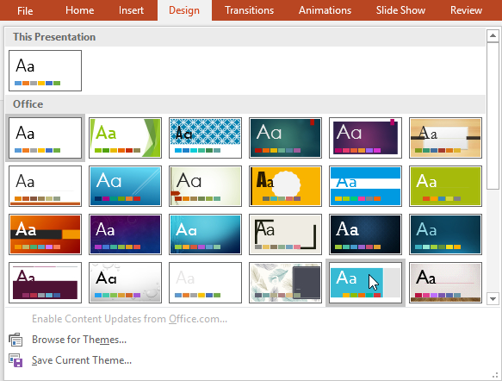

* Select the desired theme.
* The theme will be applied to the entire presentation. To apply a different theme, simply select it from the Design tab.

## *Color*

### **Purpose**

Used to change the color of a theme

### **Steps with pictures**

* Click on design tab



* Click Colors, and then click Customize Colors.

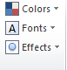

* Click the button next to the theme color you want to change
* Then pick a color under Theme Colors.

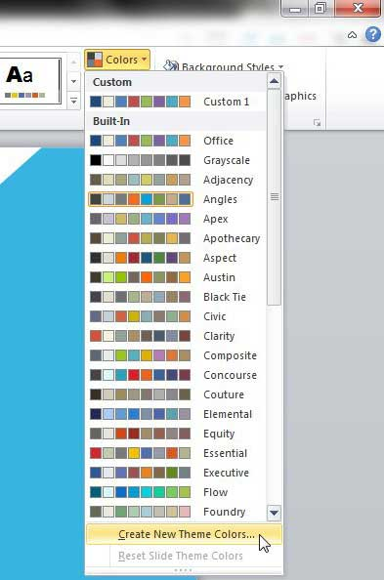

## *Font*

### **Purpose**

Used to change the font of the theme slide

### **Steps with pictures**

* Click on the design tab



* Click on font

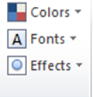

* Click on the font that you wanted to select

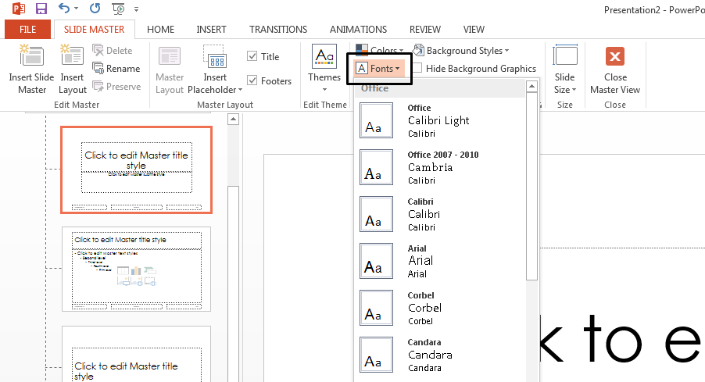

* Click okay

## *Effect*

### **Purpose**

Used to apply A effect on a theme

### **Steps with pictures**

* From the Design tab click the drop-down arrow in the Variants group and select Effects.



* Select the desired theme effects.

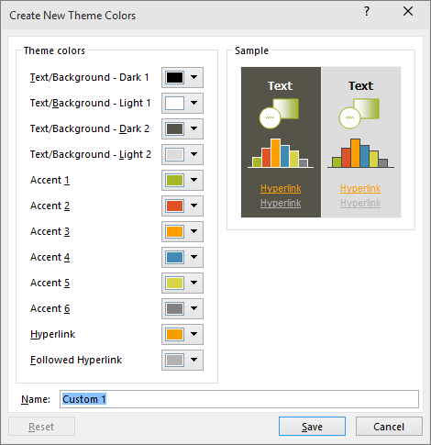

* Click on save to apply the changes

### Transitions Tab

#### Preview

|  |
| --- |
|  |

**Preview** - Preview the slide transitions for the active slide.

#### Transition to this slide

|  |
| --- |
|  |

Transition are used to make slide more productive.

**Transition Scheme** - gallery  
**Effect Options** -

**Transitions**

To add a special effect, to transition from one slide to another:

1. Select the slide you want to add a transition to.
2. On the **Transitions** tab, select the effect you want.
3. Select **Effect Options** to change how the transition happens: **From Right**, **From Left**, ...

To undo a transition, select **None**.

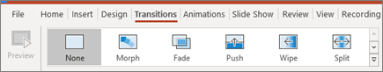

#### To apply a transition:

1. Select the **desired slide** from the **Slide Navigation** pane. This is the slide that will appear **after** the transition.

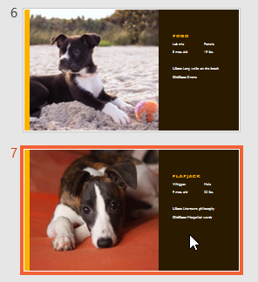

1. Click the **Transitions** tab, then locate the **Transition to This Slide** group. By default, **None** is applied to each slide.
2. Click the **More** drop-down arrow to display all transitions.

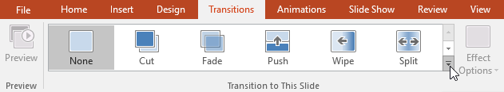

1. Click a**transition**to apply it to the selected slide. This will automatically preview the transition.

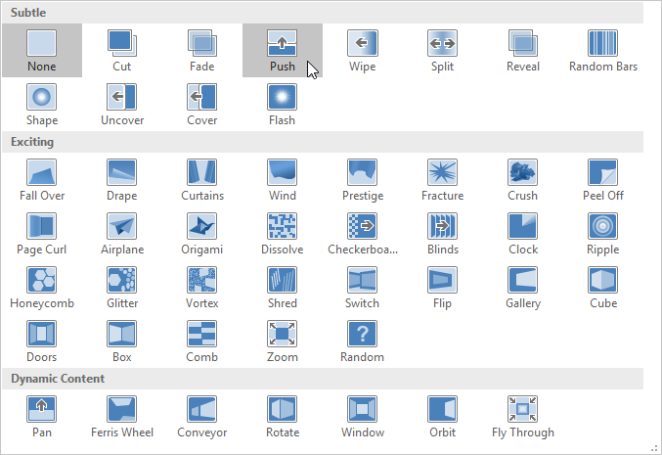

You can use the **Apply To All** command in the **Timing** group to apply the same transition to all slides in your presentation. Keep in mind that this will modify any other transitions you've applied.

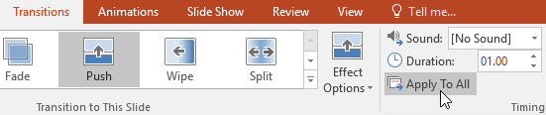

Try applying a few different types of transitions to various slides in your presentation. You may find that some transitions work better than others, depending on the content of your slides.

#### To preview a transition:

You can **preview** the transition for a selected slide at any time using either of these two methods:

* Click the **Preview** command on the **Transitions** tab.

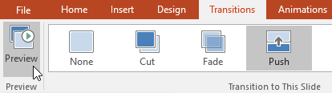

* Click the **Play Animations** command in the **Slide Navigation** pane.

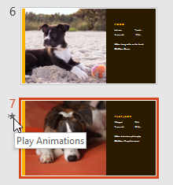

### Modifying transitions

#### To modify the transition effect:

You can quickly customize the look of a transition by changing its **direction**.

1. Select the **slide** with the transition you want to modify.
2. Click the **Effect Options** command and choose the desired option. These options will vary depending on the selected transition.

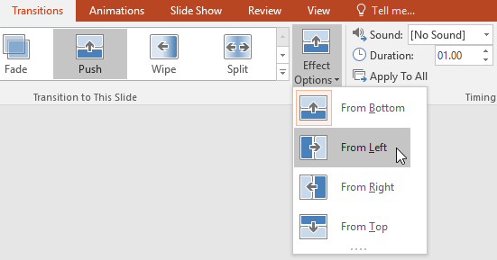

1. The transition will be **modified**, and a **preview** of the transition will appear.

Some transitions do not allow you to modify the direction.

#### To modify the transition duration:

1. Select the **slide** with the transition you want to modify.
2. In the **Duration** field in the **Timing** group, enter the **desired time** for the transition. In this example, we'll decrease the time to half a second—or 00.50—to make the transition **faster**.

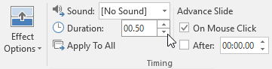

#### To add sound:

1. Select the **slide** with the transition you want to modify.
2. Click the**Sound** drop-down menu in the **Timing** group.
3. Click a **sound** to apply it to the selected slide, then preview the transition to hear the sound.

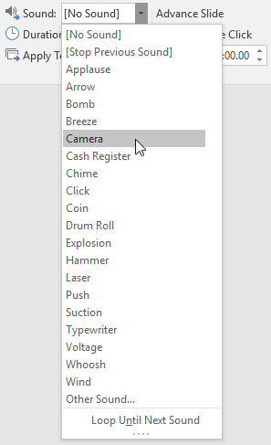

Sounds are best used in moderation. Applying a sound between every slide could become overwhelming or even annoying to an audience when presenting your slide show.

#### To remove a transition:

1. Select the **slide** with the transition you want to remove.
2. Choose **None** from the **Transition to This Slide** group. The transition will be removed.

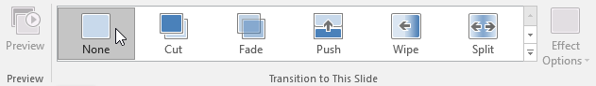

To remove transitions from **all slides**, apply the **None**transition to a slide, then click the **Apply to All** command.

#### Timing

|  |
| --- |
|  |

**Sound** – by use of this option we can enable sound to our slide when we moved one slide to next slide then it gives some sound on that moving.  
**Duration** -  
**Apply to All** - Set the transition between all the slides in the presentation to be the same as this slide.  
**On Mouse Click** - Lets you wait until there is a mouse click before moving on to the next slide.  
**After** -Lets you move to the next slide after a specific number of seconds.

**National University of Modern Languages**

Advancing in MS Power Point

# Week 7

**National University of Modern Languages Sector H-9, Islamabad, Pakistan.**



**Department of Software Engineering**

**Course Title: Introduction to Information & Computer Technology**

**Student Name: Hamza Mehmood**

**Roll Number: SP-21-110**

**Lab Number: WEEK-5 Date:**

**Lab Assessment Rubrics**

**Method:** Lab report and instructor observation during Lab session **Outcome Assessed:**

1. Ability to analyze and design solutions to conduct experiments (Psychomotor).
2. Ability to perform in a team (Affective).
3. Ability to apply and comprehend modern engineering tools to develop skills for engineering knowledge and being able to design report and documentation (Psychomotor).

|  |  |  |  |  |
| --- | --- | --- | --- | --- |
| **Performance** | **Exceeds Expectation (4-5)** | **Meets Expectation (2-3)** | **Does not meet Expectation (1)** | **Marks** |
| 1. Realization of  Experiment [c] | Chooses the required yet relevant equipment to perform the experiment establishes setup diagrams of equipment connection or wiring. | Effective guidance is required to choose relevant tools for the experiment and also to develop well connected wiring diagram. | Fails to select the required equipments/ tools to perform the experiment or wiring diagram seriously lack clarity or appear ambiguous. |  |
| 2. Teamwork [b] | An active cooperation develops among group members to support the execution of the experiment. | Effectively cooperates with the group members  to perform the experiment. | Negatively affects the other group members and creates hindrance in successful performance or completion of experiment. |  |
| 3. Conducting Experiment [a] | A careful selection of equipment, wiring is done under supervision of instructor for effective operation and task completion. | Carefully examines the  equipment, wiring of all components and calibrate experiments with very few errors. | Incapable of calibrating the suitable equipment and wiring with inaccurate equipment operation. |  |
| 4. Laboratory  Safety Rules [a] | Safety rules and procedures are carefully observed during the experiment. | Scrutiny observes the prescribed safety measures with very minor deviation. | Does not observe the safety rules during experiments. |  |
| 5. Data Collection  [a] | Data collection is carefully planned to achieve experimental objective. | Data collection is carefully planned to get experimental objectives with very minor mistakes. | Incapable of planning the data collection to acquire the experimental objective or the collected data is inappropriate or incomplete. |  |
| 6. Report writing  [c] | Properly written with all results. | Writing report with minor error. | Incomplete Lab report |  |

**Total Marks Obtained:**

**Instructor’s Signature:**

### Animations Tab

#### Preview

|  |
| --- |
|  |

**Preview** - Preview the slide animations for the active slide.

#### Animation

|  |
| --- |
|  |

**Animation Styles** - gallery  
**Effect Options** –

**Animations**

To animate text or objects on a slide:

1. Select the text or object you want to animate.
2. On the **Animations** tab, select **Add Animation**, and select the animation you want from the drop-down.

To animate one line of text at a time, select one line of text, select an animation, select the next line of text, select an animation, ...

1. For **Start**, select **When Clicked**, **With Previous**, or **After Previous**.

You can also select the **Duration** or **Delay**.

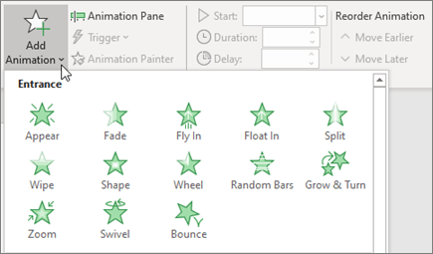

*Advanced Animation*

|  |
| --- |
|  |

**Add Animation** -  
**Animation Pane** -  
**Trigger** -  
**Animation Painter** –

1. Select the shape or object you want to add an animation to.
2. Go to **Animations** > **Advanced Animation** > **Add Animation** and select the animation you want to add.
3. Next, go to **Animations** > **Advanced Animation** > **Animation Pane**.

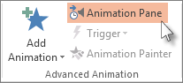

1. In the **Animation Pane**, select the animated shape or other object that you want to trigger to play when you click it.
2. In the **Advanced Animation** group, click **Trigger**, point to **On Click**, and then select the object.

### Trigger an animation to begin during a video or audio clip

To trigger an animation effect to play during a video or audio clip, you must first insert a bookmark at the desired point in the clip.

1. [Add a bookmark to your video or audio clip](https://support.microsoft.com/en-us/office/add-bookmarks-to-points-of-interest-in-audio-and-video-clips-eafb434f-5038-4c6a-93d0-428a9b68b7fa) for where you want to trigger an animation effect to begin.
2. Go to **Animations** > **Advanced Animation** > **Animation Pane**.
3. In the **Animation Pane**, select the animation effect that you want to begin at a certain point during the audio or video clip.
4. In the **Advanced Animation** group, click **Trigger**, point to **On Bookmark**, and select the bookmark that you want to trigger the animation to begin.

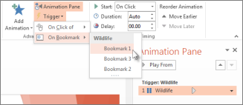

*Timing*

|  |
| --- |
|  |

**Start** -  
**Duration** - (Transition Speed in 2007)  
**Delay** -  
**Move Earlier** -  
**Move Later** -

Slide Show Tab

#### Start Slide Show

|  |
| --- |
|  |

**From Beginning** - Start the slide show from the first slide.  
**From Current Slide** - Start the slide show from the active slide.  
**Broadcast Slide Show** - (Removed in 2010).  
**Custom Slide Show** - Drop-Down. The drop-down contains the commands: Custom Shows. Custom Shows displays the "Custom Shows" dialog box.

#### Setup

|  |
| --- |
|  |

**Set Up Slide Show** - Displays the "Set Up Show" dialog box.  
**Hide Slide** - Hides the current slide from the slide show. Hidden slides are indicated in the top left corner.  
**Record Narration** - (Removed in 2010).  
**Rehearse Timings** - Launches a full screen slide show allowing you to rehearse the transitions.  
**Use Rehearsed Timing** - (Removed in 2010)  
**Record Style Show** -  
**Play Narrations** -  
**Use Timings** -  
**Show Media Controls** –

*Monitors*

|  |
| --- |
|  |

**Resolutions** - Displays a list of available resolutions.  
**Show On** - (Show Presentation On in 2007).  
**Use Presenter View** - Toggles the display of speaker view on a second monitor.

### Review Tab

#### Proofing

|  |
| --- |
|  |

**Spelling** - (F7) it is use for spelling checker.  
**Research** - Toggles the display of the Research task pane.  
**Thesaurus** - (Shift + F7). Toggles the display of the Research task pane defaulting the research service to the thesaurus.

*Window*

|  |
| --- |
|  |

**New Window** - Opens a new window containing a view of the current presentation.  
**Arrange All** - Tile all open windows side by side on the screen.  
**Cascade** - Cascade all the open windows so they overlap.  
**Move Split** - Move the splitters to separate the different parts of the window.  
**Switch Windows** - Drop-Down.

**New Window** To open a new PowerPoint window, click this button. A new window will open with the same presentation. The presentation will have a number after the name.

**Arrange All** Click this button to tile the open windows on the screen side-by-side.

**Cascade Use** this button to tile the open windows so that they overlap vertically on the screen.

Move Split This option is used to move the splitters that separate the different sections of the window.

**Switch Windows** Click this button to switch from one window to another window. A list of the open windows will display when the button is clicked.

**Macros**

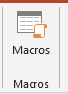

**Macros** These are miniature programs that are used to perform specified tasks within a program. Examples of Macros are Ctrl + P for print or Ctrl + S for save. When this button is clicked, a list of macros will be displayed.

**End of Report**

**Thank you.**